**EX NO 8 :**

**Write a C program to identify whether a given line is a comment or not.**

**INPUT :**

### 

OUTPUT :

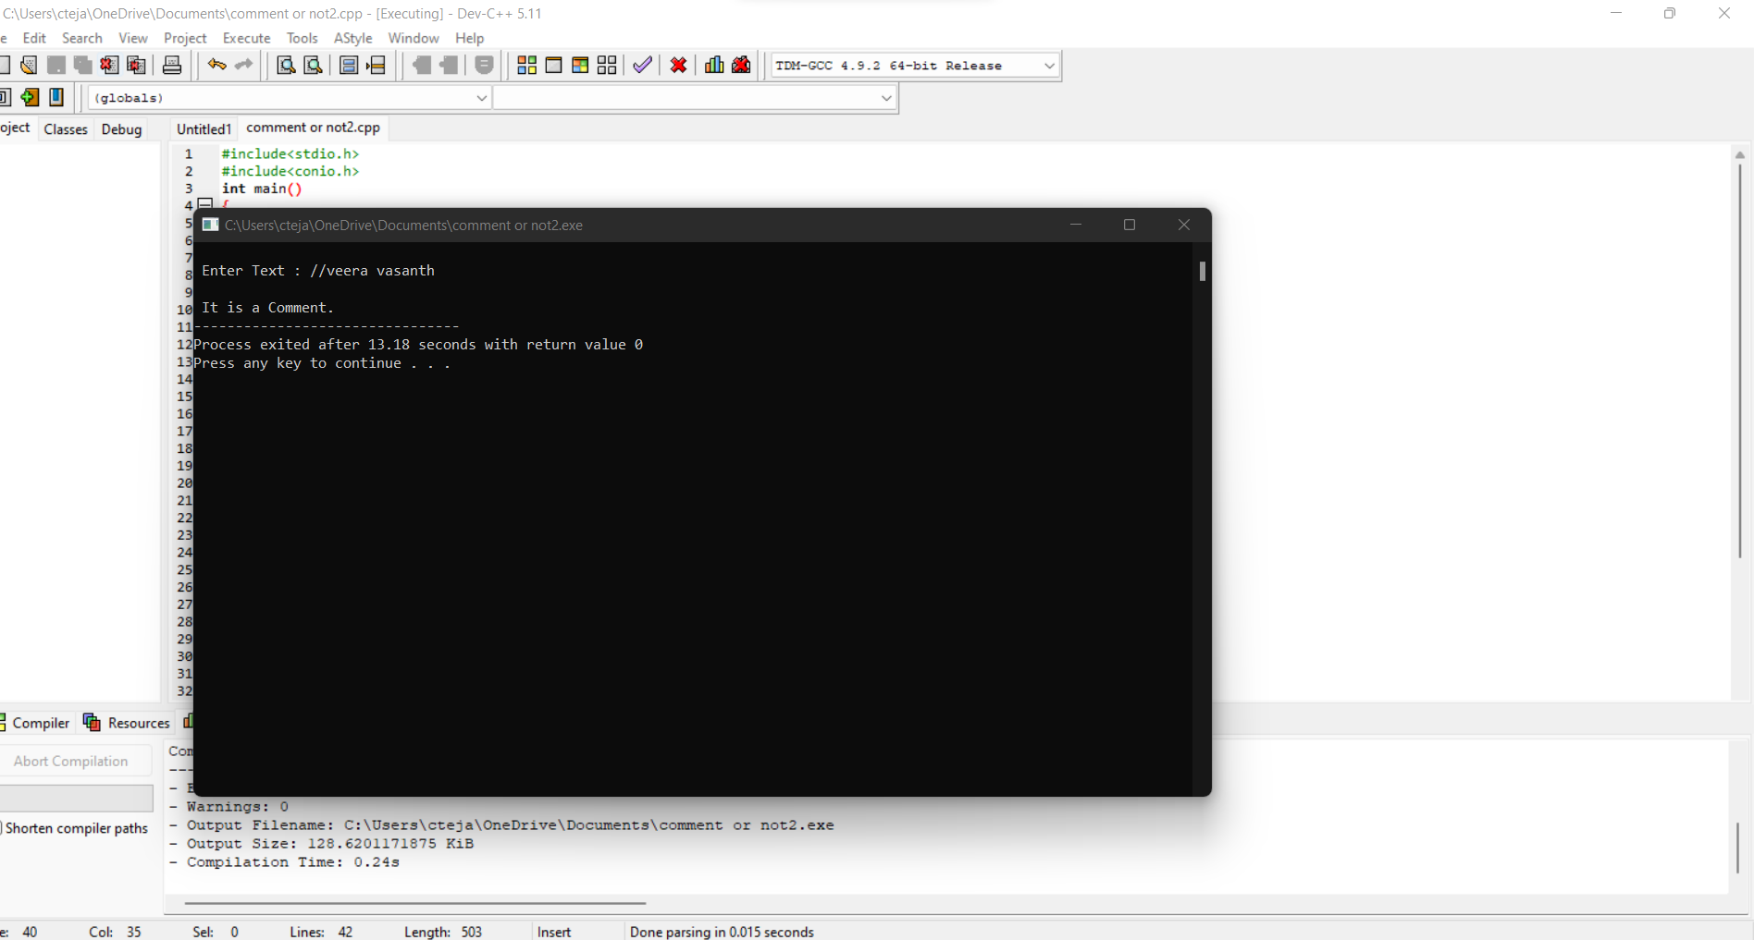

## 

**EX NO 9:**

Write a C program to test whether a given identifier is valid or not.

INPUT :

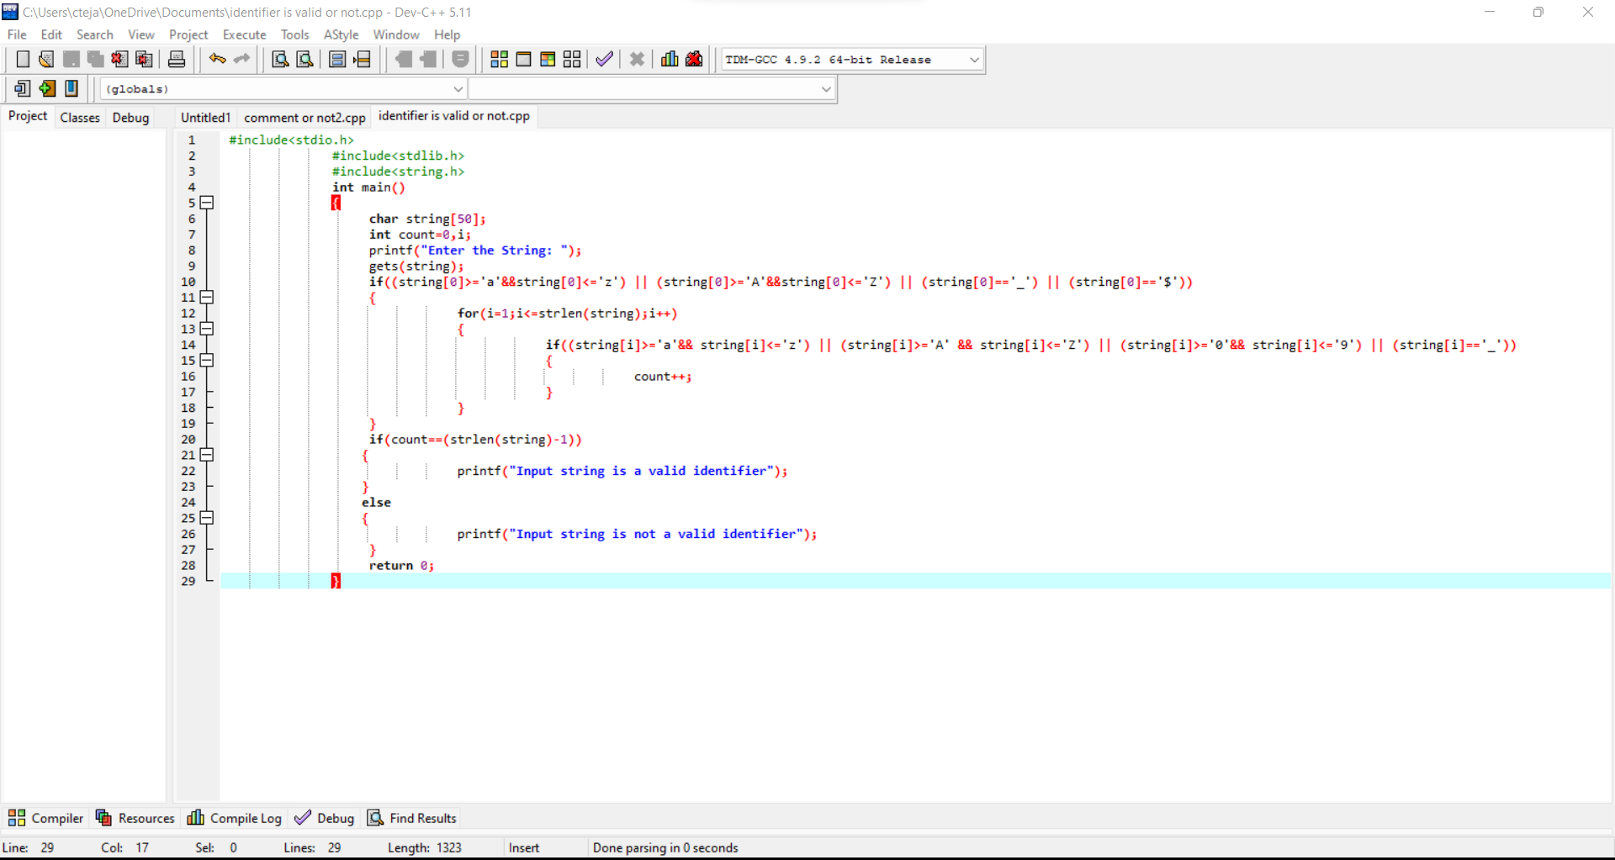

Output :

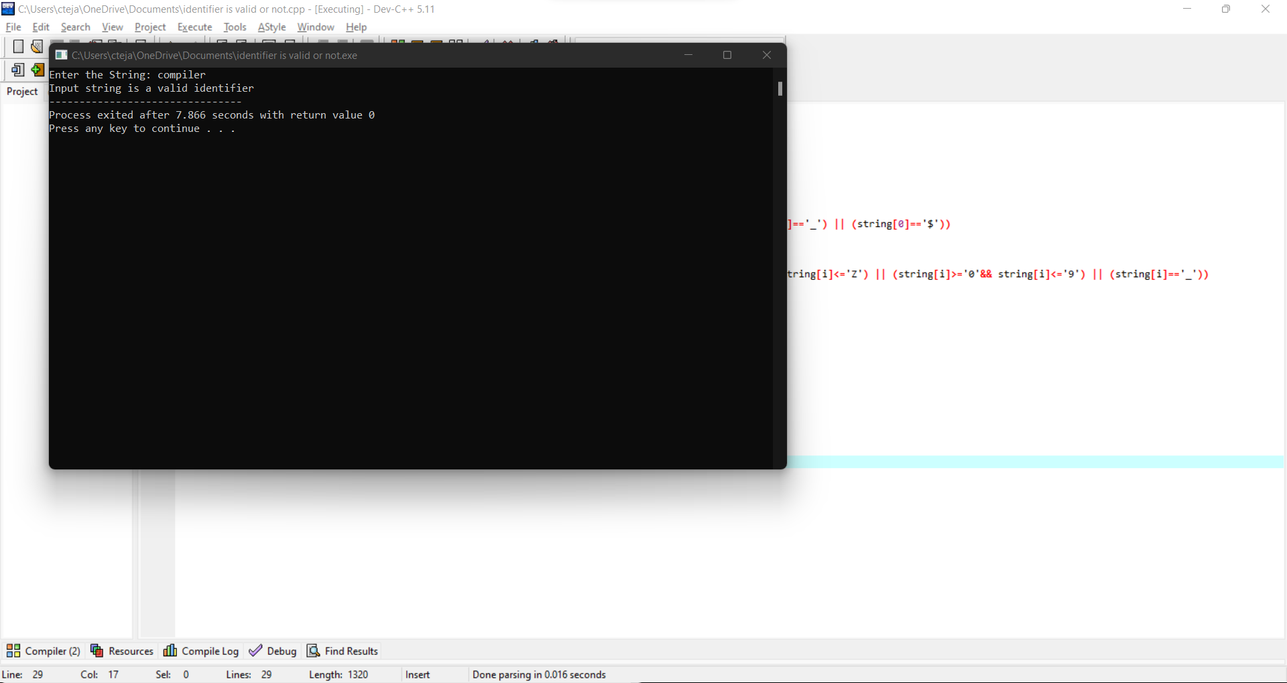

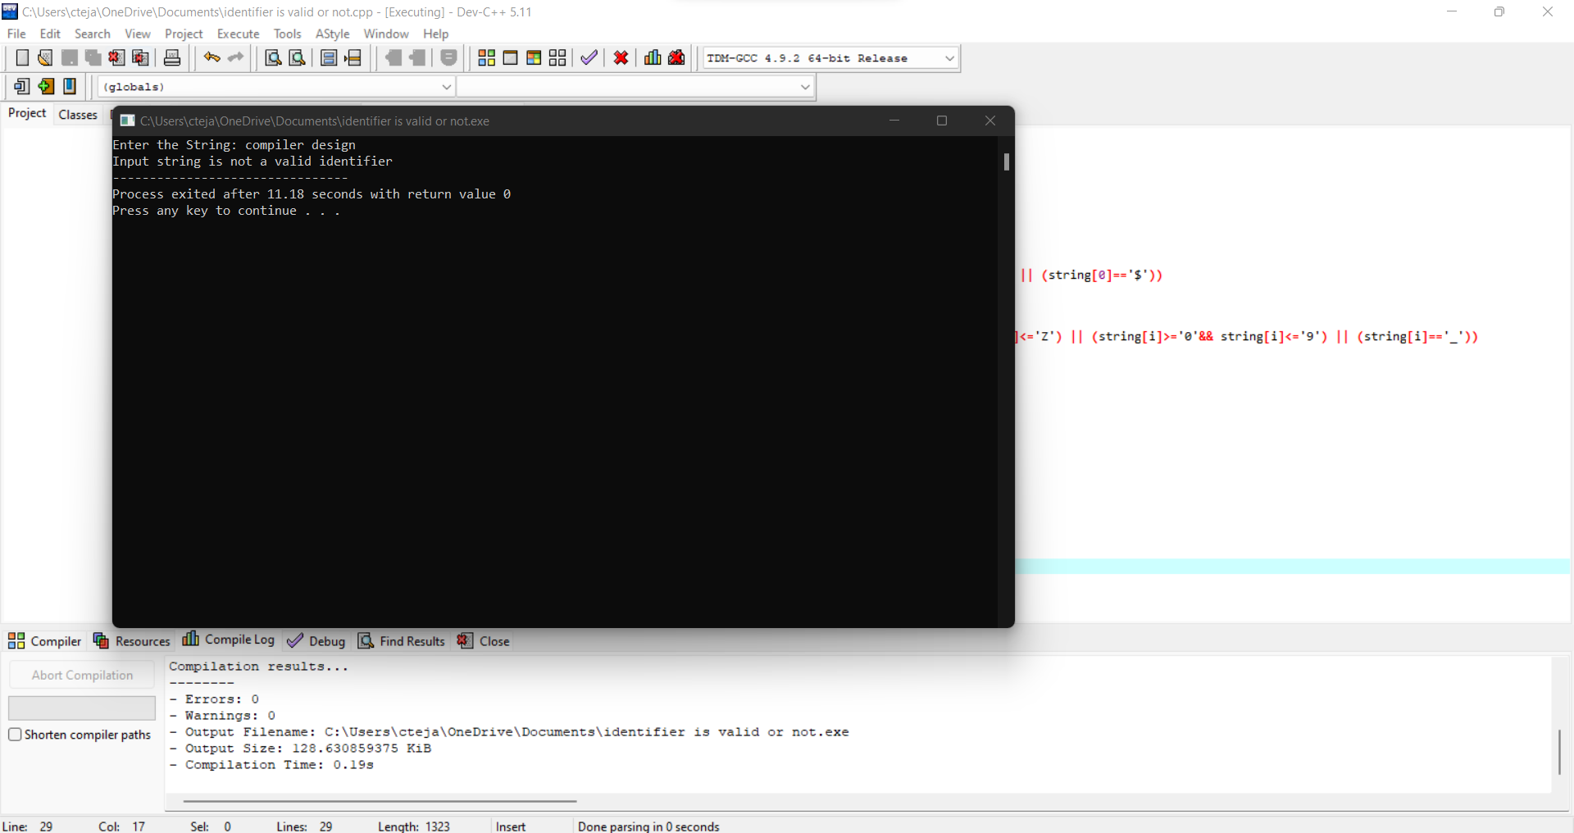

EX NO 10 :

Write a C program to validate operators.

INPUT :

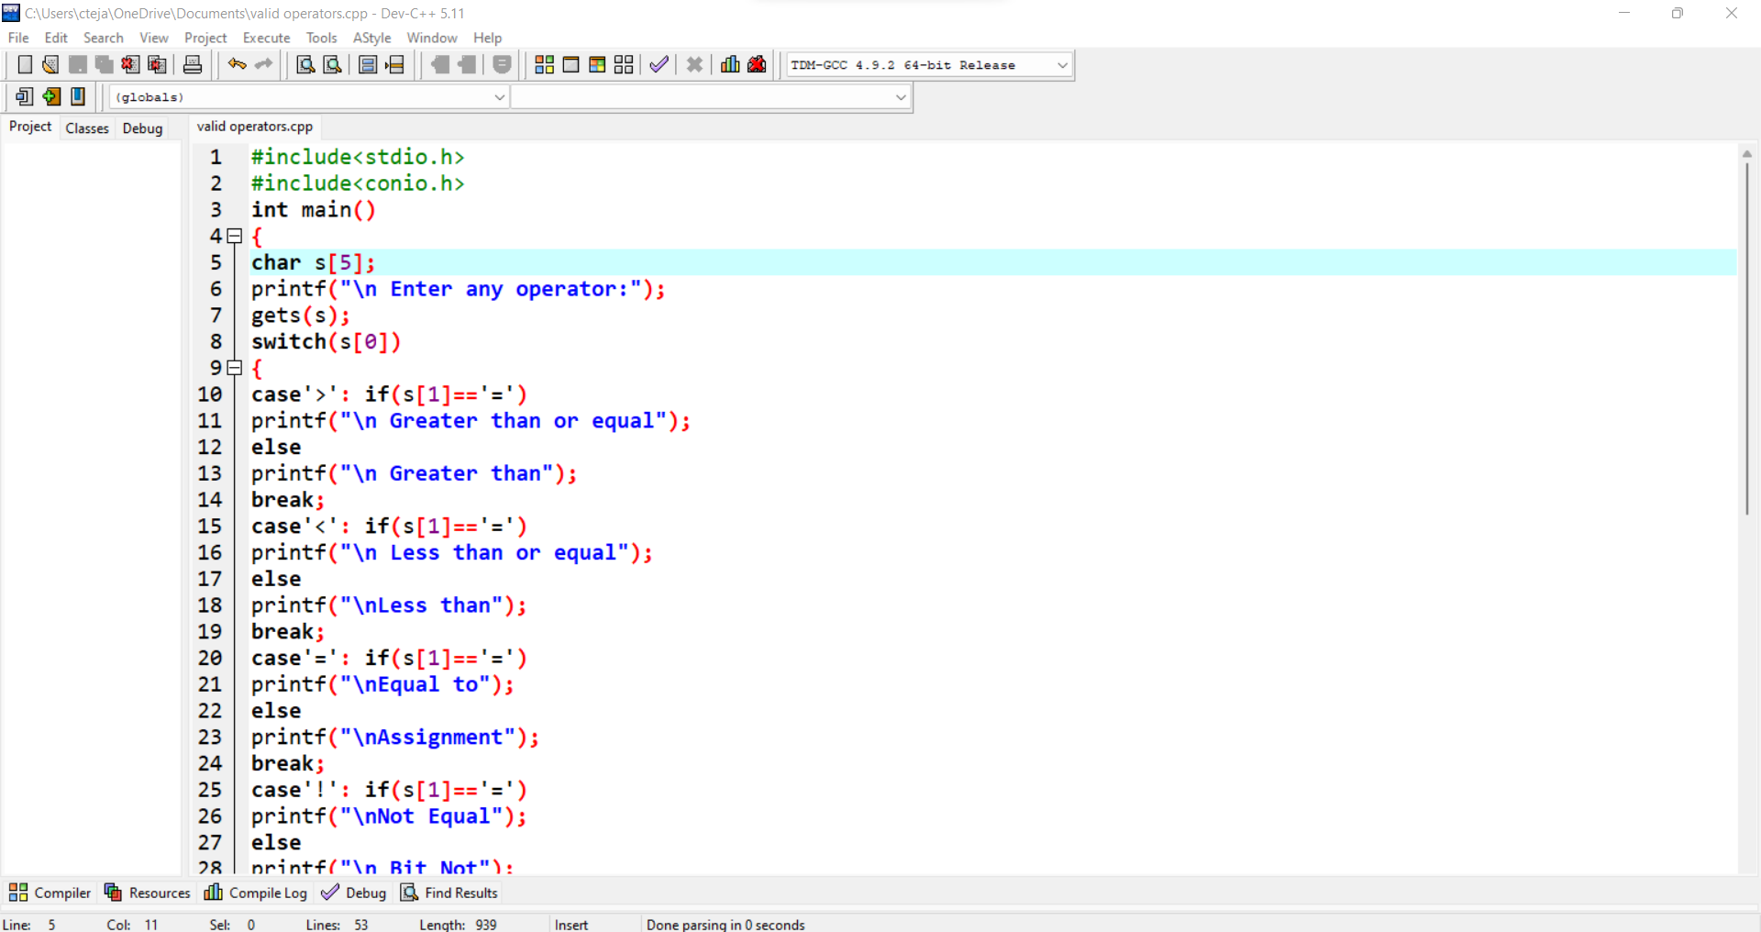

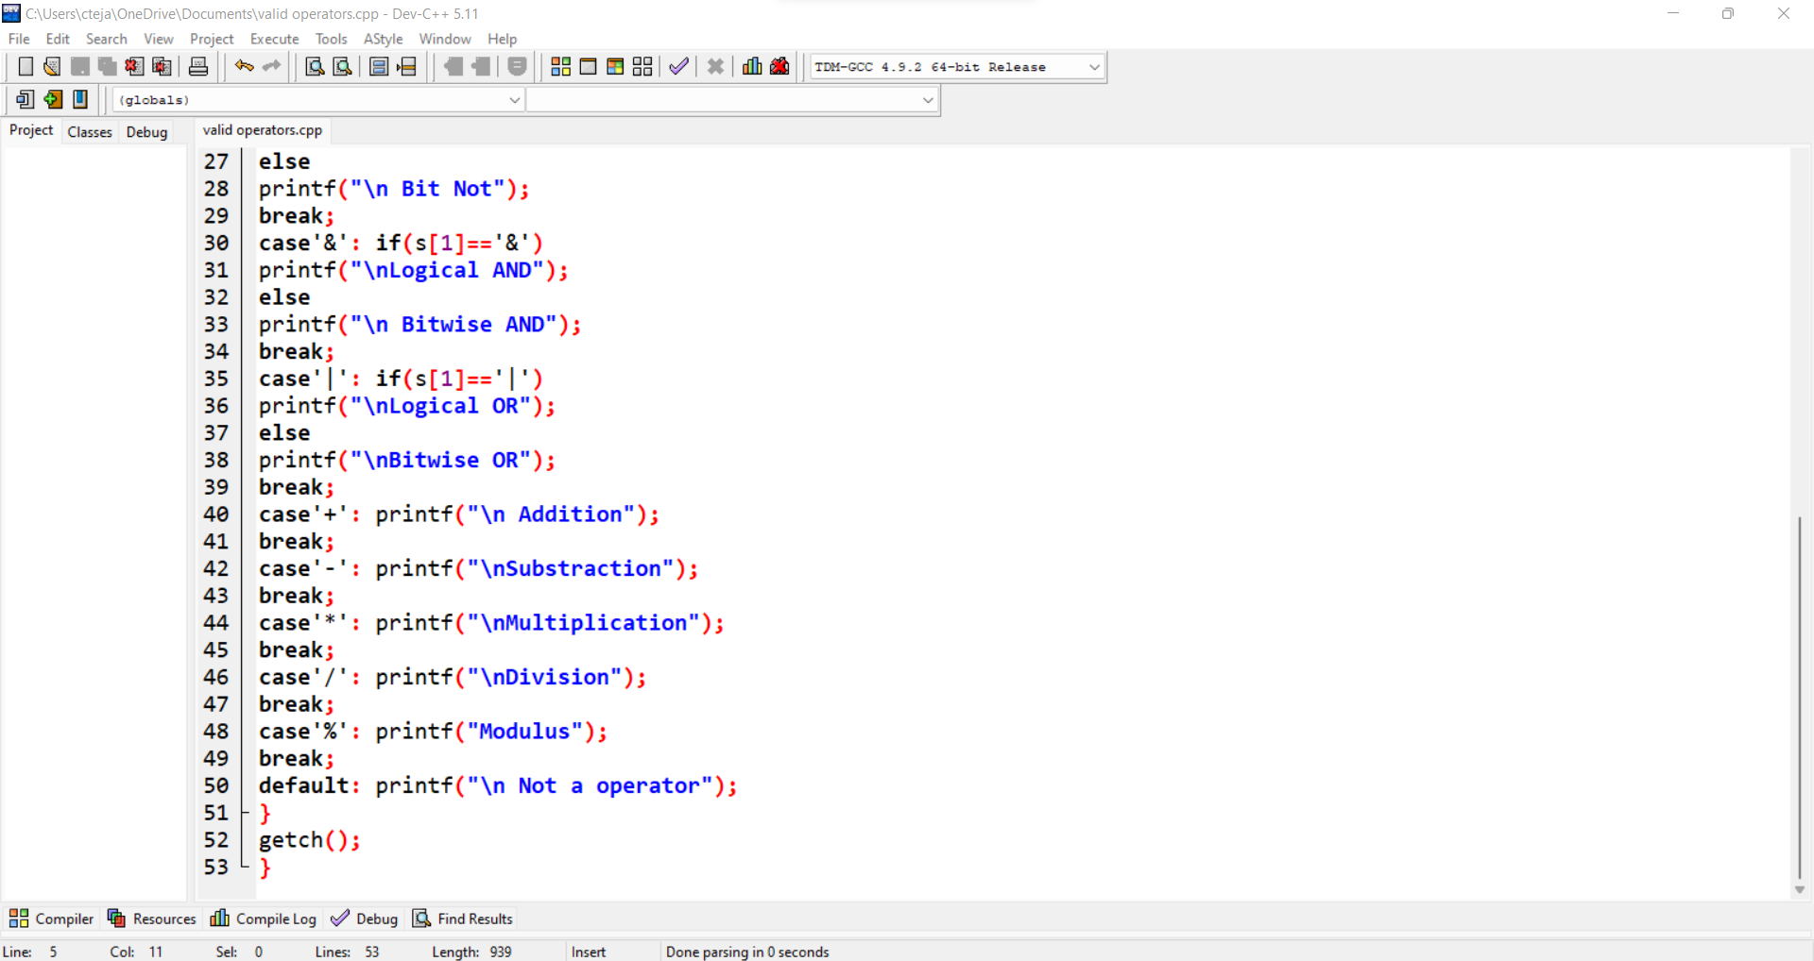

OUTPUT :

